The below picture shows the global wind patterns in a certain month.

A student concludes that the figure is representative for the Northern hemisphere summer.

*Is he right?*

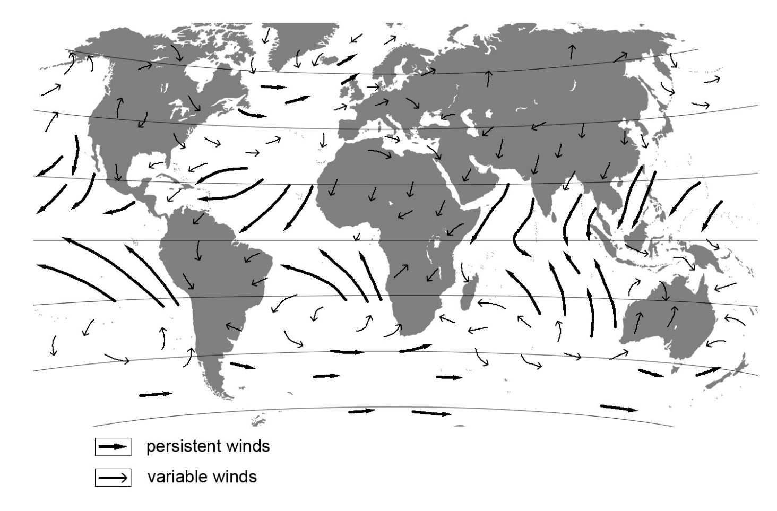

|  |  |  |
| --- | --- | --- |
|  |  | No |
|  |  | There is not enough information to draw a conclusion |
|  |  | Yes |

FOR NH summer, strong winds should blow towards the Asian land mass. This picture depicts NH winter.

*On open coasts, a storm wave environment may result in:*

|  |  |  |
| --- | --- | --- |
|  |  | dynamic sandy coastal profile |
|  |  | muddy coasts |
|  |  | breaking waves tend to be of the plunging type |
|  |  | lower wave steepness |

Storm wave environment

* Higher wave energy
* Episodic events
* High wave steepness

The form factor *F* is used to classify tides.

It is defined as *F*=(*K1*+*O1*)/(*M2*+*S2*) where the symbols of the constituents indicate their respective amplitudes.

Four categories are distinguished:

|  |
| --- |
| **Value of F** |
| 0-0.25 |
| 0.25-1.5 |
| 1.5-3 |
| >3 |

Now consider the following tidal record:

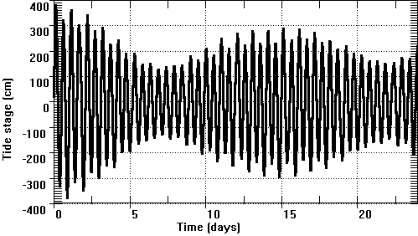

*Which value for F is most likely for this record?*

|  |  |  |
| --- | --- | --- |
|  |  | 27.32 |
|  |  | 0.1 |
|  |  | 1.1 |
|  |  | 2.8 |

Compare a tide-dominated and a wave-dominated open coastal stretch.

*The wave-dominated coast probably:*

|  |  |  |
| --- | --- | --- |
|  |  | has a steeper slope: TRUE |
|  |  | has a steeper slope: FALSE |
|  |  | consists of finer material: TRUE |
|  |  | consists of finer material: FALSE |

Wave-dominated > more energy to change the slope steepness, and material is coarser